BANNER SUPPLY CO., INC. YOUNGSTOWN 03/02/20

ROLL OFF RENTAL
Weekly Rental – 7 Calendar Days

Construction Debris Only
Size | W/ >15sq Shingle Purch  Local Calcutta/E Liv |  | Price-Regular
6 Yd Construction Debris Only | 240.00 | 255.00 | 260.00
10 Yd Construction Debris Only | 270.00 | 285.00 | 290.00
12 Yd Construction Debris Only | 300.00 | 315.00 | 320.00
16 Yd Construction Debris Only | 342.00 | 355.00 | 360.00
20 Yd Construction Debris Only | 390.00 | 405.00 | 410.00

Trash / Clean Outs
Size | Price-Regular
6 Yd Non Construction Debris / Trash | 260.00
10 Yd Non Construction Debris / Trash | 290.00
12 Yd Non Construction Debris / Trash | 320.00
16 Yd Non Construction Debris / Trash | 360.00
20 Yd Non Construction Debris / Trash | 410.00

Size | Style | Approx. Box Dimensions | App Sq of Shingle/Box
6 Yd | V Box | 7 ½ ft Wide x 13 ft Long x 2 ft High | 21 Sq
10 Yd | V Box | 7 ½ ft Wide x 14 ft Long x 3 ½ ft High | 35 Sq
12 Yd | V Box | 7 ½ ft Wide x 14 ft Long x 4 ft High | 42 Sq
15 Yd | Sq Box | 7 ½ ft Wide x 13 ft Long x 4 ft High | 52 Sq
16 Yd | V Box | 7 ½ ft Wide x 16 ft Long x 4 ½ ft High | 56 Sq
20 Yd | V Box | 7 ½ ft Wide x 15 ft Long x 6 ft High | 70 Sq

Move (one job to another) | 89.00
Move (change position of Roll Off on same job) | 69.00
Fuel Surcharge - Local | 19.95
Fuel Surcharge – Extended | 29.95
Shingle/Siding Disposal Charge per Square | 14.00
* NO BOXES BIGGER THAN 10 YD FOR CONCRETE,
DIRT, BRICK, BLOCK OR ASPHALT*

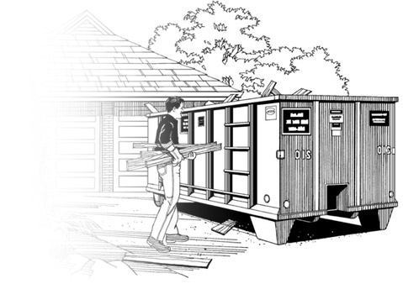
ROOFING 21

